Single Cycle CPU Design
1. Here we have a single cycle CPU diagram. Answer the following questions:
a. Name each component. (3 points)
b. Name each datapath stage and explain its functionality. (5 points)
c. Provide data inputs and control signals to the next PC logic. (3 points)
Fig. 1 Single Cycle RISC-V Datapath
Single Cycle CPU Control Logic
4. Fill out the values for the control signals from the previous CPU diagram. (8 points)
Instrs. | Control Signals
Instrs. | BrEq | PCSel | ImmSel | BrUn | ASel | BSel | ALUSel | MemRW | RegWEn | WBSel
addi | X | +4 | I | X | Reg | Imm | Add | Read | 1 | ALU
and | X | +4 | X | X | Reg | Reg | And | Read | 1 | ALU
lw | X | +4 | I | X | Reg | Imm | Add | Read | 1 | MEM
sw | X | +4 | S | X | Reg | Imm | Add | Write | 0 | X
beq | 1 | ALU | B | X | PC | Imm | Add | Read | 0 | X
jal | X | ALU | J | X | PC | Imm | Add | Read | 1 | PC+4
jalr | X | ALU | I | X | Reg | Imm | Add | Read | 1 | PC+4
lui | X | +4 | U | X | X | Imm | B | Read | 1 | ALU

(Put an X if the signal doesn’t matter)
Clocking Methodology
- The input signal to each state element must stabilize before each rising edge.
- Critical path: Longest delay path between state elements in the circuit.
- If we place registers in the critical path, we can shorten the period by reducing the amount of logic between registers.

Single Cycle CPU Performance Analysis
5. The delays of circuit elements are given as follows:
Stage | IF | ID | EX | MEM | WB
Delay | 200 | 100 | 200 | 300 | 100
a. Mark the stages the following instructions use and calculate the time to execute. (8 points)
Instruction | IF | ID | EX | MEM | WB | Total
addi | X | X | X |  | X | 600
and | X | X | X |  | X | 600
lw | X | X | X | X | X | 900
sw | X | X | X | X |  | 800
beq | X | X | X |  |  | 500
jal | X | X | X |  | X | 600/500
jalr | X | X | X |  | X | 600/500
lui | X | X | X |  | X | 600

b. Which instruction(s) exercises the critical path? (3 points)
Load word (lw), as it both reads from memory and writes to register, which most instructions don’t use both memory and writing to register.

c. What is the fastest you could clock this single-cycle datapath? (3 points)
1/900ps = 1.11GHz

d. Why is a single cycle CPU inefficient? (3 points)
Not all instructions exercise the critical path, but we have to clock to the slowest instruction. It is not parallelized, but we can use each component concurrently

e. How can you improve its performance? (3 points)
We can use pipelining, which involves putting registers between two stages → reducing
the clock time for each stage

6. A single cycle RISCV datapath is illustrated in Fig. 1. Now we have the time information for each component tabulated in the Table below.
Element | Register clk-to-q | Register Setup | MUX | ALU | Mem Read | Mem Write | RegFile Read | RegFile Setup
Parameter | t_{clk-to-q} | t_{setup} | t_{mux} | t_{ALU} | t_{MEMread} | t_{MEMwrite} | t_{RFread} | t_{RFsetup}
Delay(ps) | 30 | 20 | 25 | 250 | 400 | 500 | 200 | 50

a. What’s the clock time and frequency of a single cycle CPU (ignore the branch comp and imm.)? (10 points)
tclk,single >= tPC, clk-to-q + tIMEMread + tRFread + tmux + tALU + max {tDMEMwrite, tIMEMread + tmux + tRFsetup}
= 30 + 400 + 200 + 25 + 250 + max{500, 400 + 25 + 50} = 1405 ps
fclk,single = 1/tclk,pipe <= 1/ (1405 ps) = 711.7 MHz

b. If the branch comp, imm., and the control need 50 ps, 100 ps, and 250 ps, respectively. Which instructions below needs longest processing time? Please explain. (12 points)
addi, jalr, lui, lw, sw
addi: tclk,single >= tPC, clk-to-q + tIMEMread + max{tRFread, timm} + tctrl + tmux + tALU + tmux + tRFsetup = 30 + 400 + max{200, 100} + 250 + 25 + 250 + 25 + 50 = 1230 ns
jalr: tclk,single >= tPC, clk-to-q + tIMEMread + max{tRFread, timm} + tctrl + tmux + tALU + tmux + t_{RF}setup = 30 + 400 + max{200, 100} + 250 + 25 + 250 + 25 + 50 = 1230 ns
lui: tclk,single >= tPC, clk-to-q + tIMEMread + timm + tctrl + tmux + tALU + tmux + tRFsetup = 30 + 400 + 100 + 250 + 25 + 250 + 25 + 50 = 1130 ns
lw: tclk,single >= tPC, clk-to-q + tIMEMread + max{tRFread, timm} + tctrl + tmux + tALU + tDMEMread + tmux + tRFsetup = 30 + 400 + max{200, 100} + 250 + 25 + 250 + 400 + 25 + 50 = 1630 ns
sw: tclk,single >= tPC, clk-to-q + tIMEMread + max{tRFread, timm} + tctrl + tmux + tALU + tDMEMwrite + tRFsetup = 30 + 400 + max{200, 100} + 250 + 25 + 250 + 500 + 50 = 1705 ns

Digital Circuit Design
10. Create an XOR gate using only NAND gates. (6 points)
F=A XOR B= AB’+A’B=((AB’)’(A’B)’)’

Therefore, five NAND gates are required to create an XOR.
B’=NAND(B,1)
A’=NAND(A,1)
AB’=NAND(A,NAND(B,1))
A’B=NAND(B,NAND(A,1))
F=NAND(NAND(A,NAND(B,1), NAND(B,NAND(A,1)))

11. How many different two-input logic gates can there be? How many n-input logic gates? (6 points)
A truth table with n inputs has 2^{n} rows. Each logic gate has a 0 or a 1 at each of these rows. Imagining a function as a 2^{n}-bit number, we count ${2^{2}}^{n}$ total functions, or 16 in the case of n = 2.

12. Draw an FSM for outputting a 1 whenever we have three repeating bits as the most recent bits, a 2 whenever we have 010 or 101, and a 0 otherwise. You may not need all states. (12 points)
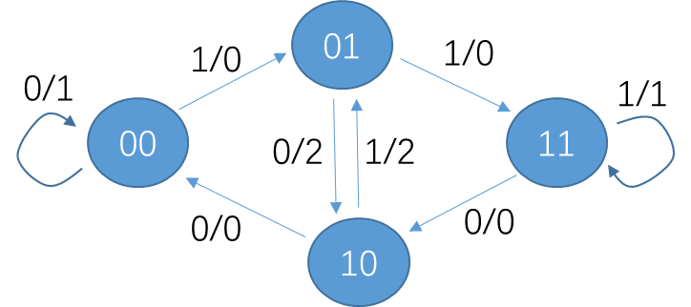

00: the most recent two bits are 00
01: the most recent two bits are 01
10: the most recent two bits are 10
11: the most recent two bits are 11

13. Fill out the timing diagram for the circuit below: (9 points)
+---+ +---+ +---+
IN-|D Q|-s0-|D Q|-s1-|D Q|--Out
+-^-+ +-^-+ +-^-+
| | |
CLK--+--------+--------+

clk
in
s0
s1
out
(Delay one cycle)

14. Fill out the timing diagram for the circuit below: (6 points)

+---+ +---+
A--|D Q|-R1-|D Q|-R2--
+-^-+ +-^-+
| |
CLK--+---|>o--+

clk
!clk
A
R1
R2
(Delay half cycle)

